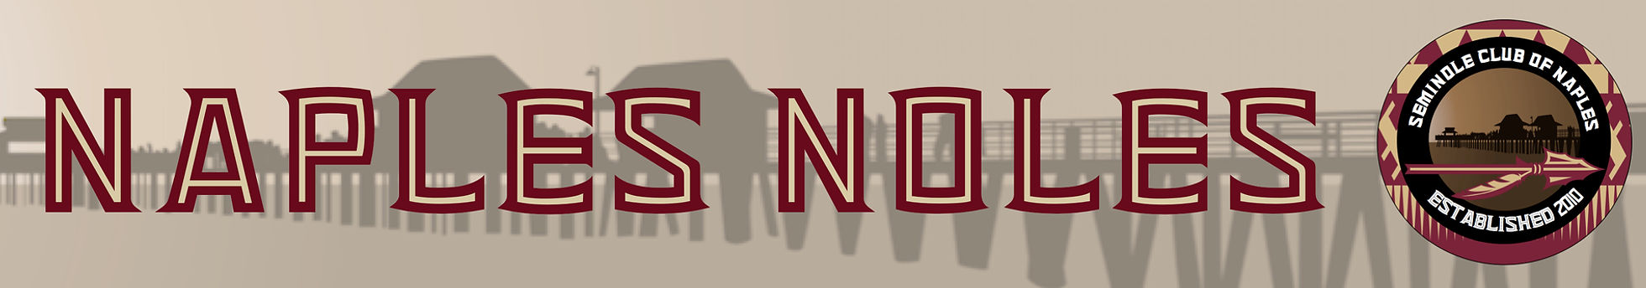
Seminole Club of Naples
Spring Golf Tournament
May 13, 2022 at Quail Creek Country Club, Naples
All proceeds benefit the Seminole Club of Naples & Seminole Boosters; both clubs are Non-Profit Organizations & Contributions are tax deductible. All proceeds support FSU Athletics, scholarships, and local Seminole Club operations.
1:00 Shotgun Start, Check in Begins at Noon, Cocktails/BBQ and Awards at the conclusion of play
Name____________________________________________________________Phone_____________________

Address_____________________________________________________________________________________
Street City State Zip Code
Email___________________________________________________________

Level: Foursome ______ Individual______ Sponsor________
$800 $200

Playing Partner: __________________________________________________

Playing Partner: __________________________________________________

Playing Partner: __________________________________________________

Check Amt: ________Credit Card Amt: ______________Exp Date: _____________________Code: _____________

Visa/MC#: __________________________________________Signature: _________________________________

I would like to donate the following for the FSU Silent Auction: ________________________________________________________________

Registration and payment may also be made at naplesnoles.com.

*** New this year—we will be having a helicopter ball drop during the tournament. Balls will be purchased up until the tournament begins. All balls will be numbered. A helicopter will then take all of the numbered balls and drop them onto a green. The ball that is closest to the pin will receive $1000 prize! In the event of a tie, then the pot will be split equally. Balls are $25 each. Purchase as many as you want.

I would like to purchase ________ golf balls. $25.00 each

Sponsorship Opportunities:
- TOURNAMENT TITLE SPONSOR $5,000
- Renegade Sponsor $1,000
- Hole Sponsor $250 (Includes two signs)
- Specialty Sponsor: Hole in One Sponsor, Longest Drive Sponsor, Closest to the Pin Sponsor
*** See Sponsorship information for more details.
NAME ON SPONSORSHIP:______________________________________________________________

Please return this form by Monday, May 9, 2022
Please make all checks payable to: Seminole Club of Naples.
Mail information to:
Kathleen Burmeister
6481 Autumn Woods Blvd.
Naples, Florida 34109Email questions to: Kathleeni3@aol.com or call 239-641-2814

